三上 Unit 3 My friends Period 1 &Phonics(Ee)
溧阳市西平小学 蒋益华
教学目标：
1.听懂、会说、会读、会用日常交际用语：He’s... He’s my friend. She’s... She’s my friend。
2.会读，会演、理解story time板块故事。
3.能正确朗读字母Ee,了解字母Ee的发音，帮助学生逐步建立字母和音素的关系，体验字母e在单词中的读音，为实现见词能读，见音能写打下基础。
4.这是开学第三周，关注学生听、读、演等课堂良好习惯的培养。
5.引导学生正确理解“friend”的意义。
教学重难点：
1.会正确区分运用“He’s/She’s ”进行日常交际。
2.使学生能建立字母Ee和因素e之间的对应关系。
教学准备：课文人物头饰、奖品小象贴纸
教学过程
Step1 Warm up
1. Greeting
2.Enjoy an English song. After that,discuss:what is it about?
Teach: friend——friends
3.Present the title of this Unit.
Step 2 Presentation
- Revision(play with old friends)
- Play games about letter friends
T: I know you have some letter friends. Who are they? Aa Bb Cc Dd
Game1:打地鼠
Game2:Chant about them
- Play games about character friends
Game1: Look at their shadows and say their names.
Game2:Think and discover:老师在介绍这些朋友时有什么不一样？
①Teach:he’s &she’s ② practise
2.Presentation( Make friends)
(1)Watch and choose
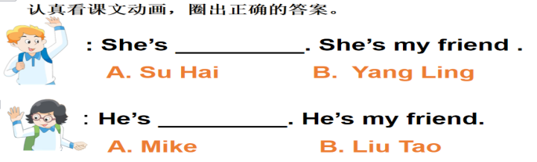
T:You know how to introduce friends correctly. What about Mike and Yang Ling?
Who’s Mike’s friend?
Who’s Yang Ling’s friend?

（2）Guess think and say
①T: How does Mike introduce his friend to Dad? What about Yang Ling?
(电脑呈现图三，去掉文字，只放Mike 的气泡框,将Yang Ling 圈起来）
T: Look，Mike is introducing his friend to Dad. What can he say? Can you guess?
T: Let's have a look. Are you right? （S read the sentences together）
(电脑呈现图四，去掉文字，只放Yang Ling 的气泡框, 将Mike 圈起来）
T: Look，Yang Ling is introducing her friend to her mum . What can she say? Can you guess?
②Think and say:What will their parents say to their children?
T:Try to have more friends and get along well with them.进行情感升华
(4)Say a rhyme
She’s, she’s, she’s Yang Ling.Friend, friend, she’s my friend.
He’s,he’s, he’s Mike.Friend, friend, he’s my friend.
(5)Listen and repeat
Read the story in different ways
跟读、指导读、小组读
Step3 Introduce New friends
1.Ask students Introduce their friends.
2. The teacher introduces her friend.
It’s an animal. It’s Elephant.
3.Teach：Ee
4.Talk about sound of letter Ee
5.Chant about Ee
Step4 Summary
Step5 Homework
1. Read and recite U3 Story time.
2. Review the rhyme of Ee..
3. Preview Fun time and make a friend card like that.

