课题 | 六下Unit7 Summer holiday plans
教学内容 | Grammar time & Fun time |  | 执教 |  | 刘萍  （溧阳市汤桥小学）
教学目标
1. 结合story time的本文复习，熟练运用一般将来时态各种句式表达，并自行归纳出语法使用规律。
2. 在询问、互动表达中了解他人的假期计划，以达到对一般将来时问句的熟练运用。
3. 进一步理解和掌握假期出游计划维度的多样性，学会制定一个全面而周密的出游计划。
教学重难点
1.结合story time的本文复习，熟练运用一般将来时态各种句式表达，并自行归纳出语法使用规律。
2.在询问、互动表达中了解他人的假期计划，以达到对一般将来时问句的熟练运用。
教学准备
PPT、视频、任务单、板书卡纸等
教学环节 |  | 教师活动 |  | 学生活动 |  | 设计意图
Step 1  Warm up  &Review  （复习板块） |  | - Greeting  2.明确学习目标及学习方法：T: Last class,we talked about summer holiday. Do you know what will do we in this class? Can you guess? You can guess like this “Will we....?”  T: Here’s the plan for this English class. In this class, we will learn Grammar time and Fun time. First, we will retell the story. Second, we will ask and answer the questions with “will”. Third, wewill talk about our summer holiday plans. And how will we learn? We will listen carefully and show ourselves actively. Can you do it?  - Show time  T: OK. Now first please take out your mind map and try to retell the story in group of four. This is one of the homework of Story time. Which group want to have a try?  - Retell the story  T: Now this time let’s try to retell the story together. |  | Students guess the plans.  S1: Will we…  S2: Will we…  S3: Will we…  S4: Will we…  Ss try to retell the story in group of four.  S1: Mike will go back to London. He will stay there for a month.  S2: Yang Ling will go to Beijing by train.  S3：Su Hai will go to Hong Kong wither her family. She will go to Disneyland and Ocean Park.  S4: Liu Tao will go to Taipei with his parents. He will take some photos.  Ss retell the story together. |  | 通过让学生猜测这节课的学习人任务，提前感知Will的一般疑问句的问答，并向学生展示这节课的学习目标和要求，帮助学生明确这节课的学习目的。  通过第一课时课后作业的展示，既检验了学生的学习成果，又帮助复习了第一课时所学内容。
Step2 Presentation  （提炼规则） |  | 1.Grammar time  (1)Let’s PK  T:OK. You all did a good job. Now let’s play a game. Let’s have a PK. Boys against girls. You can ask and answer questions about Story time with the sentence patter “Will...” , for example, Will Mike go back to London? Do you understand? Here we go.  (2)Let’s think  T: Wonderful. You can ask and answer so many questions. Now please look at these sentences. What can you find? Can you find out the sentence structure?  Rule 1：  Will+主语+动词原型...?  Yes,...will./No,...won’t.  (3)Let’s PK  T:Now let’s play the game again. This time you can ask and answer questions about Story time with the Wh-question, for example, How long will Mike stay in London?Ready? Go!.  (4)Let’s think  T: Now please look at these sentences. What can you find? Can you find out the sentence structure?  Rule 2：  特殊疑问词+will+主语+动词原形...?  主语+will+动词原形...  2.Fun time  (1)Free talk  T: We know Mike will go to London. Yang Ling will go to Beijing. Su Hai will go to Hong Kong. Liu Tao will go to Taipei. Where will you go for the summer holiday?  (2)Play a game  T: OK. Do you like games? Let’s play “Super Brain” together. First, let’s know something about the rules.(详细解释一下游戏规则)  ★  I’ll go to...(country/city/place)  I’ll go to...He’ll go to...  ★★  I’ll go to...with...by...  I’ll go to...with...by...He’ll go to...with...by...  ★★★  I’ll go to...with...by...and stay there for...  I’ll go to...with...by....and stay there for...He’ll go to...with...by...and stay there for...  (3)show the game  T: Time’s up. Which group want to have a try? Which level do you choose? One star, two stars or three stars?  3.Miss Liu’s plan  (1)Play the guessing game  T: Do you want to know Miss Liu’s summer holiday plans? I won’t tell you. You have to guess. Now work in group of four, discuss and write down four questions, you can ask Yes or No questions and Wh-question. Ask Miss Liu 4 questions one by one and then at last guess the destination. Understand? OK, now discuss with your group members.  (2)Fill in the blanks  T: Oh, you are so smart. Yes, Miss Liu will go to Hong Kong. Do you have any other questions to ask Miss Liu? Now can you help Miss Liu finish the writing? |  | Ss ask and answer questions about Story time with the sentence patter “Will...”.  S1:Will Mike go…?  S2:Will Yang Ling buy…?  S3:Will Su Hai eat…?  Ss try to conclude the rules.  Ss ask and answer questions about Story time with the sentence patter “Wh-question”.  S1:Where willMike go…?  S2:How willYang Linggo …?  S3:What will Su Haido…?  Ss try to conclude the rules.  Ss answer the questions.  S1:I will go to....  S2: I will go to...  Ss play the game in group of four.  S1:I will go to Beijing.  S2:I will go to Shanghai. He’ll go to Beijing.  S3: I will go to Dalian. He’ll go to Beijing. She’ll go to Shanghai.  S4:....  Ss show their games.  Ssdiscuss and write down the questions about Miss Liu’s plans.  Ssask the questions.  Ss try to guess.  Ss try to fill in the blanks. |  | 通过游戏问答的形式，对Story time的内容进行提问，再游戏互动中感受句式规律，并自行归纳句式结构。  （达成目标1）  通过Fun time 部分的“滚雪球”游戏：描述个人假期计划+复述他人的假期计划，将一般将来时陈述句句式复习与具有挑战性的趣味游戏结合，激发了学生表达的积极性。  在询问、互动表达中了解他人的假期计划，以达到对一般将来时问句的熟练运用。  （达成目标2）
Step3: Consolidation  （实践运用） |  | 1.Let’s think  T: If we want to talk about our plans for the summer holiday, which questions can we ask?  2.Do a survey  (1)Ask and answer  T: Do you want to know more about your desk-mate's summer holiday plans? Now please do a survey. You can use these questions to ask your desk-mate.  (2)Share the dialogue  T: Would you like to share your dialogue with us?  3.Let’s think  T: What else can we plan for?  4.Let’s share  T: A good plan will make our life more colourful.  5.Ticking time  T: Here comes our Ticking time. Please take out you paper, evaluate yourself first then evaluate your desk mate. |  | Ss try to conclude.  Ss try to ask questions about their friend’s summer holiday plan.  Ss share their dialogue.  Ss share their ideas.  S1: Study plan.  S2: Weekend plan.  S3:....  Ss enjoy some picture about plans.  Ss evaluate each other. |  | 指导学生提炼假期出游计划的更多维度。  （达成目标3）  学生在询问朋友的暑假出游计划时，可以综合应用一般将来时的各种句式，多维度了解假期出游计划时，感悟到制定出游计划时要关注到丰富性、周全性。  （达成目标2和3）
Step4  Homework（巩固评价） |  | - Write a dialogue about your desk-mate's summer holiday plan.  - Make a mind map about your summer holiday plan. |  |  |  | 1.编写对话：在运用中巩固、迁移一般将来时的各种句式。  2.思维导图：从不同维度思考自己的暑期计划，为第四课时的写作做好铺垫。
板书设计 |  | 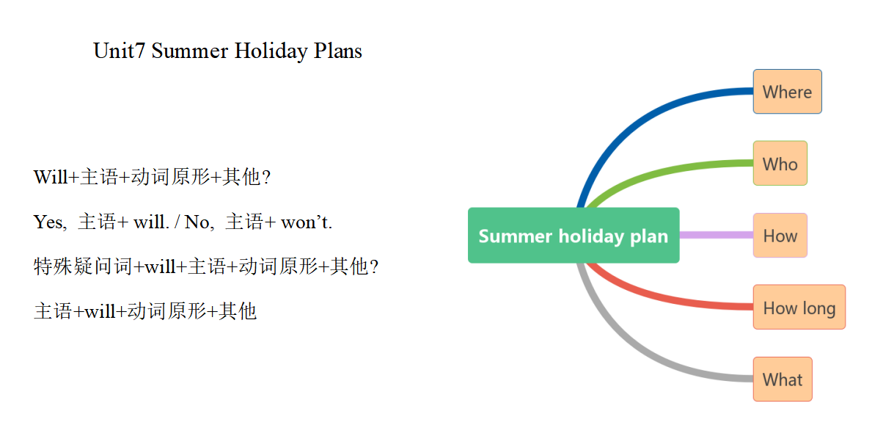

教后反思：
本课时是第二课时语法教学，个人认为是比较难上的，也是第一次尝试这种课型的公开课。一开始通过复习Storytime，让学生对Story time内容的问答，让学生体会和感知这两种句式，从而发现归纳句式结构。从反复问答—自主探究—归纳总结—综合运用，使学生体会和领悟语言形式的表意功能，使所学语法规则在真实情境中得到运用，从而达到内化规则和提高学生综合运用语言的能力。整体教学过程还是比较流畅的，但在细节处理还不是很到位，如应该帮助学生提炼出关于summer holiday plan的结构；在评价环节中做得还不够好，只是简单地学生自我打勾和同桌互相评价，流于形式。在以后的教学中会更多考虑如何在语法教学中设计更多有趣的教学活动，提高学生语法学习的实效性。

