Unit 3 A Healthy diet
( Story time)
溧阳市文化小学 潘雪姣
- 教学内容
本节课内容是Unit3 A Healthy diet 中story time板块，课文主要围绕“健康饮食”这一主题，以分别介绍Mike和 YangLing的饮食习惯为主线，围绕健康膳食金字塔的形式，讨论人们生活中的饮食习惯。学习内容贴近学生的生活，具有指导性、实用性，体现了英语课程工具性和人文性的统一。
- 教学对象
六年级的学生已经积累了一定的英语知识和英语学习方法，且此话题贴近学生的生活，能激发学生的英语表达欲望。通过学习，学生可以学到表达健康饮食的用语，了解健康饮食的标准，以此及时调整自己的饮食习惯，并能够模仿文本将学到的知识用于实际交流。
三、教学目标
1、能在整体情境中理解story time的内容，养成预测文本、处理信息等能力。
2、能听懂、会说、会读单词，词组或句型：： at a time, healthy, diet, cola, a little, a few. He has a lot of/some noodles/meat. She has a few eggs/a lettle rice.
3、能正确朗读课文，能用所学句型、交际用语等讲述自己的饮食习惯。
4、能主动参与课堂活动，与他人合作。
5、能初步了解关于健康饮食的文化与知识。
四、教学策略
1、围绕话题，情趣导入，从了解教师的饮食表导入，激发学生兴趣，给学生留下悬念，激发学生学习相关语言的欲望。
2、设计课前活动，激活学生的思维和知识储备；课堂活动注重学生的语言实践和阅读技巧的培养，培养学生用英语做事情的能力；课后活动让学生将所学语言初步运用于生活中。
3、互动合作，重视学生的思维参与度，培养学生的综合英语运用能力。
四、教学过程：
Step 1Pre-Reading
1. Greetings.
2.T asks the Ss: Were you happy at Spring Festival? I was happy at Spring Fastival. I had a long holiday and visited some interesting places with my family. But now I’m not happy. I ate too much food and got up late at this Spring Fastival. And I didn’t do any exercise. So, I’m fatter than before. It’s a bad news.
Way：a, Show the T’s diet and describe it. b, What do you think of my diet? Healthy or unhealthy?
Teach: diet, a few, a little, healthy, unhealthy.
Step2 While-reading
1.Look at Mike and YangLing’s diets.
Q:What food do they both like? Ss:...
What kind of sweet food does Mike eat? Ss:...
How much sweet food does YangLing eat? Ss:...
Way: read the text quickly and answer
2.What food do they eat for three meals?
Way: a, watch and tick b, answer
- Talk about Mike’s diet.
Q: How much bread and milk does Mike eat for breakfast?
How much meat and fish does Mike eat for breakfast?
How much rice does Mike eat for breakfast?
Way: read and under the key words.
- T: What do you think of Mike’s diet? Ss:...
What is a healthy diet?
T: In fact, it’s according to a special form--Healthy Food Pyramid
Way: show the Say something about the Healthy Food Pyramid.
What shape is it? How many floors are these?
To keep healthy, we should have a lot of rice, noodles, bread, fruit and vegetables. Because they are a good source of carbohydrates and vitamins. They keep us healthy.
We should eat some meat, fish,eggs, and milk. They can make us strong. At last, we just have a little sweet food. Because they provide calories, and they can make us fatter and fatter.
- Give Mike some advice.
Tips: Hey, you should/can... Please eat... ...can make us....Don’t...
- Talk about YangLing’s diet. Does she have a good healthy diet? Why?
Way: read and underline.
- Listen and repeat.
Tips:跟录音朗读，注意语音清楚，语调自然。
- Read freely.
a, read in parts. b, read together. c, read after one
- Retell the text.
a, look at the blackboard and retell the text. b, finish the passage
Step3 Post-reading
- Say something about your diet.
- If you have an unhealthy diet, what are you going to do?
Tips: I’m going to... I should(not)... I can(not)...
- Junk food.
To keep healthy, we should have healthy food, but no junk food.
Step4: Sum-up
Remember: Eat more healthy food. Do more exercise.
Have a healthy lifestyle. Healthy is wealthy.
Step5 Homework
1.Read the text freely.
2.Try to tell something about Mike and YangLing’s diets.
3.Say something about your diet.

板书设计
Unit3 A healthy food
Breakfast Lunch and Dinner  
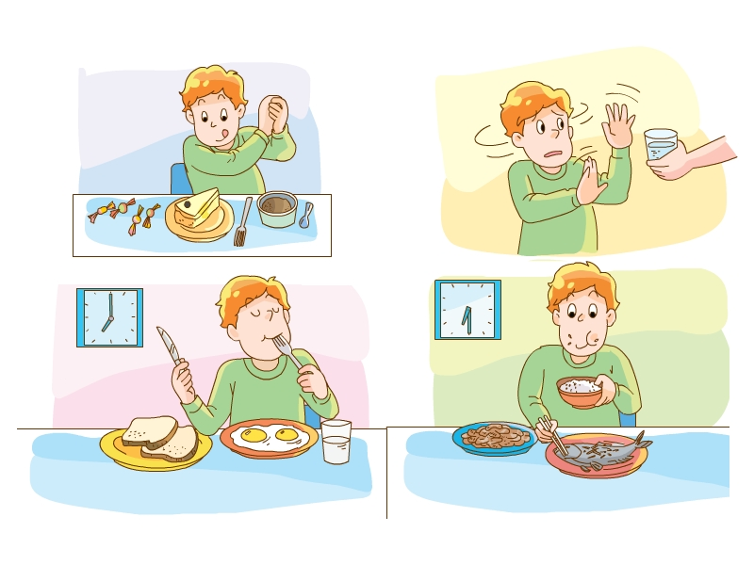 some 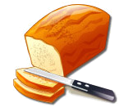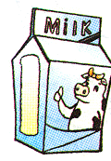 some 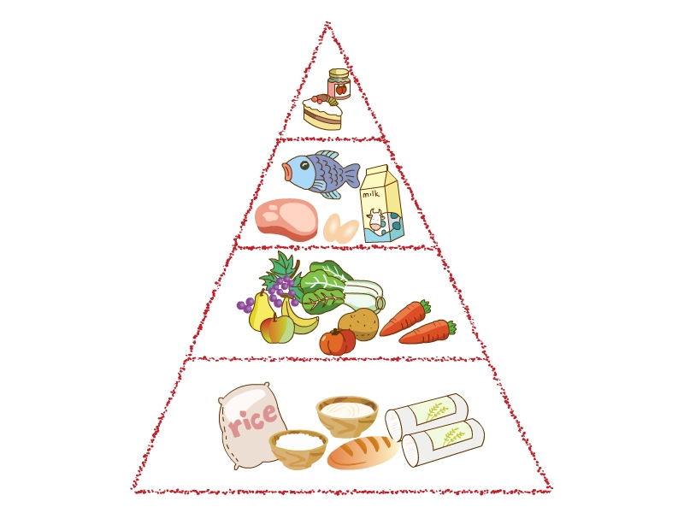  

a lot of

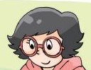 a lot of 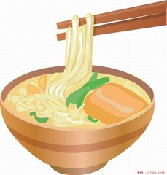 some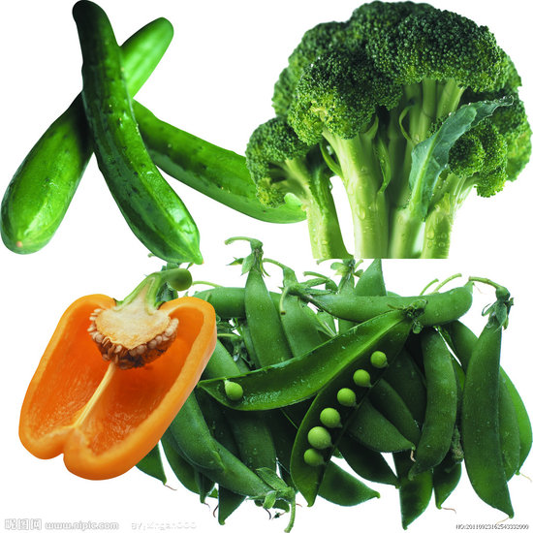
an  a little 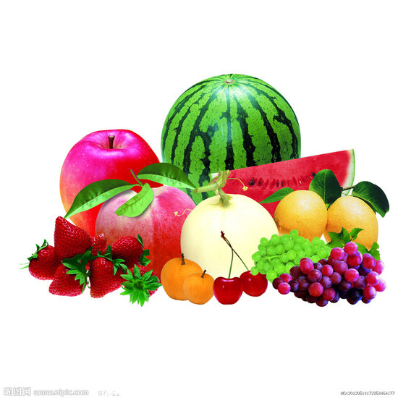

Period 2
(Grammar time &Fun time)
溧阳市文化小学 彭江炜
- 教学目标
- 学生能熟练复述story time.
- 学生能在具体情境中熟练运用a lot of, some, a few, a little。
- 学生能正确归类可数名词和不可数名词并掌握可数名词的复数形式。
- 学生能运用句型I have…for breakfast/lunch/dinner流利的说出一日三餐饮食。
- 学生能用英文了解他人的饮食习惯并提出建议。
- 教学重点
1.学生能在具体情境中熟练运用a lot of, some, a few, a little。
2.学生能用所学句型流利的介绍自己的一日三餐。
- 教学难点
  - 正确使用a few, a little。
  - 可数名词和不可数名词的区分。
四、教学准备PPT, 调查表
五、教学步骤
Step1 Free talk
1. Date/Day/Weather
T:This morning, I ate some porridge and an egg, what about you? What do you have for breakfast this morning? S1/S2
What do you think of their breakfast? Whose is healthier?
2 Review:（复习storytime）
Last lesson, we have known something about Mike and Yang Ling’s diet, let us review it.
Mike
Yang Ling
3 Now you have known Mike’s diet is unhealthy, this is his new diet, is it better than before? Why？和迈克原来的饮食对比。
 | breakfast | lunch | dinner
Mike | some bread and milk | some rice, a lot of vegetables and a little meat | Some noodles, a little sweet food and some fruit
Reason---He likes eating sweet food, he does not have any fruit or vegetables.
Now he eats a little sweet food and eat a lot of fruit and vegetables.
Step2 Grammar time
1 呈现一些食物图片，要求学生从口感和营养的角度进行描述，然后利用健康饮食金字塔的知识，从均衡饮食的监督，给出建议。
Now you know some food is good for us, some is not. Look at this pictures, which food do you like, why? Discuss in pairs. For examples:
Fish is good for us. It can make us clever. We should eat fish every day.
Carrots are sweet. They are good for our healthy. we should often eat carrots.
We all like ice cream. It’s sweet. It’s tastes nice. But we shouldn’t eat too much of it. It’s bad for our teeth. We should eat a little at a time.
Meat is full of calorie. eat too much can make people fat.
Fruit is the most natural food, Fruit makes you feel better, it’s full of water.
2 呈现实物金字塔：(food pyramid)
T:To keep healthy, we should eat a lot of rice, bread, vegetables and fruit. We should eat some meat, eggs, fish and milk. We should eat a little sweet food like sweets and cakes.
3 a few, a little, a lot of ,some 的规则变化：学生归纳
Just now, we saw many words about food.
Look at the form, can you find some rules about “a few” and “a little”.
A few+可数名词的复数， a little+不可数名词
Game 青蛙吃食
The same of “a lot of”and “some
4 出现一些单词，分类可数单词和不可数单词，并且举例
5 名词复数变化规则
If the word is uncountable, we shouldn’t plus “s” or “es ’after it.
If the word is countable, we can plus “s” or “es” after it.
以o结尾的单词，出现mango potato tomato
+es: mango potato tomato(有生命的物体)
+s: zoos photos pianos radios
6 Finish some exercise.
1 There are (some, a little) vegetables on the plate.
2 Sam had (a little, a few) bread for breakfast.
3 There are(a little, a few) eggs in the fridge.
4 Nancy often eats(a lot of, a few of) juice in summer.
5 How many (potatos, popatoes) are there in the fridge?
Step3 Fun time
1 Now you know, some food we should eat a lot, some a little or a few, what food do you usually eat a lot? What eat a little? Is your diet healthy? What about your classmates’ diet? Let’s do a survey about it.
2 What do you have for breakfast? I have…
What about lunch and dinner? For lunch and dinner, I have…
T-S,，ask and answer.
Finish the form.(a lot of 3 some 2 a little/ a few )

_____’s meals in a day
 | egg | milk | bread | noodles | vegetables | fruit | rice | meat | fish | …
breakfast
Lunch
dinner

3 talk about it.
问答Ask two pairs of them , ask and answer.
呈现T: …has…for breakfast, she has…for lunch and dinner.
What do you think of her diet? Why? Suggestions. (师叙述，学生评价)
4 让两个学生呈现出对方的饮食规律
…has…for breakfast, she has…for lunch and dinner.
What do you think of her diet? Why? Suggestions (学生叙述，学生评价)
Step3 Consolidation
I think everyone should have a healthy diet, healthy diet, healthy life！
Write down about your diet.
Tips---try to use a little/a few/some/a lot of…
usually/ sometimes/often/never…
My diet
I have a ______diet.
In the morning, I have___________.
For lunch and dinner, I have__________.
I think ________is good for us, we should_________.
We shouldn’t ____________.
Healthy diet, healthy life！

Homework：
1 Write down about your diet in a day.
2 Finish Ex book P16-17.
3 Preview cartoon time, read it after the tape.

板书设计
a little +不可数名词 What do you have for breakfast?
a few+可数名词的复数 I have…
a lot of What about lunch and dinner?
some 不可数名词/ For lunch and dinner, I have…
可数名词的复数

Period 3
(Sound time Culture time and Cartoon time)
溧阳市文化小学 谢娟
一、课时目标
1、学生能熟练地用所学语言来谈论自己的饮食习惯和什么是健康的饮食。
2、学生能掌握字母组合“ou”的发音规律，并能举一反三。
3、学生能了解本单元文化知识：中西方早餐食物的差异。
4、学生能在情景中自主理解故事大意，并通过自主阅读，强化语言知识，训练语言技能，培养学生的阅读理解能力。
二、教学重难点
1、学生能掌握字母组合“ou”的发音规律，并能举一反三。
2、学生能了解本单元文化知识：中西方早餐食物的差异。
3、学生能在情景中自主理解故事大意，并通过自主阅读，强化语言知识，训练语言技能，培养学生的阅读理解能力。
三、教学准备：PPT,照片等
四、教学过程：
Step 1Revision
- Today we go on learning “healthy diet”. What is a healthy diet?(出示金字塔图，与学生谈论)
- Last lesson, you all did a survey for your breakfast, lunch, dinner. Please tell me what do you think about your diet? Do you have a healthy diet? How about your classmates?
- How about Miss xie? You can interview me.(出示表格)
- How about Kate？What does she have for breakfast?
Let’s listen and answer “What’s for her breakfast?”
Step 2 Culcutre time
1.This is my breakfast, Chinese breakfast. This is Kate’s breakfast，Western breakfast. What’s the difference? What can you find?
2.出示文化差异总结（Culture time）
3.This is the difference between Chinese breakfast and Western breakfast, What else do you know about the food culture?
Step 3 Cartoon time
1.Lead in
There are some differences between Chinese breakfast and Western breakfast. Do you like Chinese food or Western food? How about Sam? guess, Which one does he like? Why？
2.自读课文
What do you think of the story?
What do you know about the story?
3.再读文本，让学生自主提问：
What do they buy?
What happens at last?
4.listen to the tape and read after it.
- Add the title and the end.
6.Action
Step 4 Sound time
过渡：You all did good job, and your ends are wonderful. We can help
Sam. Maybe we can help Sam.Maybe we can go fishing for Sam. Maybe we can cook a fish for Sam. Let’s go to the kitchen.
- Show the picture of the kitchen and talk about it.
Who is in the Kitchen? What is she doing? What is she shouting?
- Listen, repeat and discuss.
What is “ou” pronounced?
- Do you know more words about…?
- Compare
Step 5 Homework
1.会四人一小组表演Cartoon time.
2.巩固ou的发音，收集含有ou发音的单词.
3.读听读空间第30页，积累更多词汇.
板书设计
Chinese breakfast (图)
Western breakfast（图）
图（Sam’s ） Supermarket drinks
图（Sam’s Mum） rice
fish

Period 4
(Checkout time & Ticking time)
溧阳市文化小学 姜蓓蓓
- 教学目标
- 能熟练运用所学知识介绍自己的饮食和健康的饮食。
- 复习并熟练运用Is/ Are there…?的句型，并能在这一句型中再一次准确运用a lot of, some, a little, a few。
- 能在笔头中准确使用there be…的结构。
- 能对本单元的学习情况做出客观、公证的自评和互评。
- 教学重点
- 复习并熟练运用Is/ Are there…?的句型，并能在这一句型中再一次准确运用a lot of, some ,a little, a few。
- 能在笔头中准确使用there be…的结构。
- 教学难点
含有a lot of, some ,a little, a few的句型的准确表达及正确运用。
- 教具准备：课件、画片、纸等
- 教学过程
Step1 Revision
1.Greeting: What date?/ How’s the weather?
2.T: What do Chinese/ Western people often have for breakfast?
S:…
3.read the words about Chinese/ Western food
4.show a proverb
Step 2 Present Bill’s diet (unhealthy)
T: Look, here areBill and Wang Bing. What are their diets? Are they healthy?
1.show a passage about Bill’s diet
2.read it freely
3.ask and answer
T: Is Bill’s diet healthy? Why?
S: …
T: Can you give some advice to him?
S: To keep healthy, you should eat/drink a lot of/ some/ a few/ a little…
You shouldn’t eat/drink too much/ too many…
T: We hope John can change his diet.
Step 3 Present Wang Bing’s diet ( healthy)
1.listen to a passage about Wang Bing’s diet （听两遍）
Q: What’s Wang Bing’s diet?
2.listen and write down some important information
For breakfast, Wang Bing usually has_______, ________ and________ .
For lunch, he eats _______, _______ and________ .
For dinner, he has _______, _______ and________ .
3.ask and answer
T: What do you think of his diet? Why?
S: …
Step 4 Checkout time—Ask and answer
T: Today Wang Bing and his family buy some food and drinks in the supermarket. What do they buy? Can you guess?
1.the students guess: Is/Are there …?
( 学生用there be…结构的一般疑问句来猜，并要求他们用上a lot of/ some/ a few/ a little)
2.show the things they buy
T:Wang Bing’s family buy lots of food and drinks. Let’s have a look.
（出示食物，最后将这些食物组成一个金字塔）
3.describe the food pyramid in pairs
Step 5 Checkout time—Look and write
1、出示空白饼图，教师示范贴图
T: We have a lot of food. Let’s put them on the right places. I put them here, because carrots are good for our body, we should eat a lot of carrots every day.
2、同桌合作贴图（同时指名一组同桌上黑板贴图）
S1: Where can you put it/them?
S2: I can put it/them here. Because…
3.talk about the picture
4.write something about the picture
5.check the answer
Step 6 Design a healthy diet
T: You know a lot about a healthy diet. At the beginning of the lesson, we found John’s diet was unhealthy. Can you design a healthy diet for him?
1.give a model: show the teacher’s diet
2.design it by yourself
3.show the design
Mike’s diet
Breakfast | Lunch | Dinner
4.describe it to us
Step 7 Ticking time
T: Look at today’s learning aims. How many starts can you get?
Homework:
- 将为John设计的健康饮食写成一篇小短文。
- 根据Ticking time中的要求自主复习。

板书： Unit 3 A healthy diet
Is/ Are there …? Yes,there is./are.
No, there isn’t./ aren’t.

